**📄 VPN Privacy & Security Report**

**Name:** Divyanshu singh  
**Topic:** VPN Use for Privacy and Secure Browsing  
**Date:** 4 July 2025

**🔸 1. VPN Client Used**

* **Service Chosen:** ProtonVPN (Free Tier)
* **Platform:** Windows 11

**🔸 2. Steps Taken**

| **Step** | **Action** |
| --- | --- |
| 1 | Signed up at [protonvpn.com](https://protonvpn.com) |
| 2 | Downloaded and installed ProtonVPN client |
| 3 | Logged in and connected to the **Free pajan server** |
| 4 | Verified IP change using <https://whatismyipaddress.com> |
| 5 | Browsed websites to confirm encrypted traffic |
| 6 | Disconnected VPN and compared original IP and browsing speed |

**🔸 3. IP Address Before and After VPN**

| **Status** | **IP Address** | **Location** |
| --- | --- | --- |
| Before VPN | 192.168.217.127 | India |
| After VPN | 149.88.103.34 | Tokyo,japan |

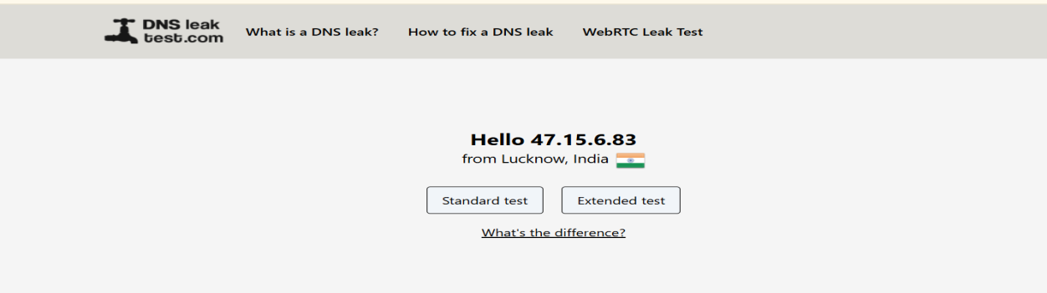

Before VPN

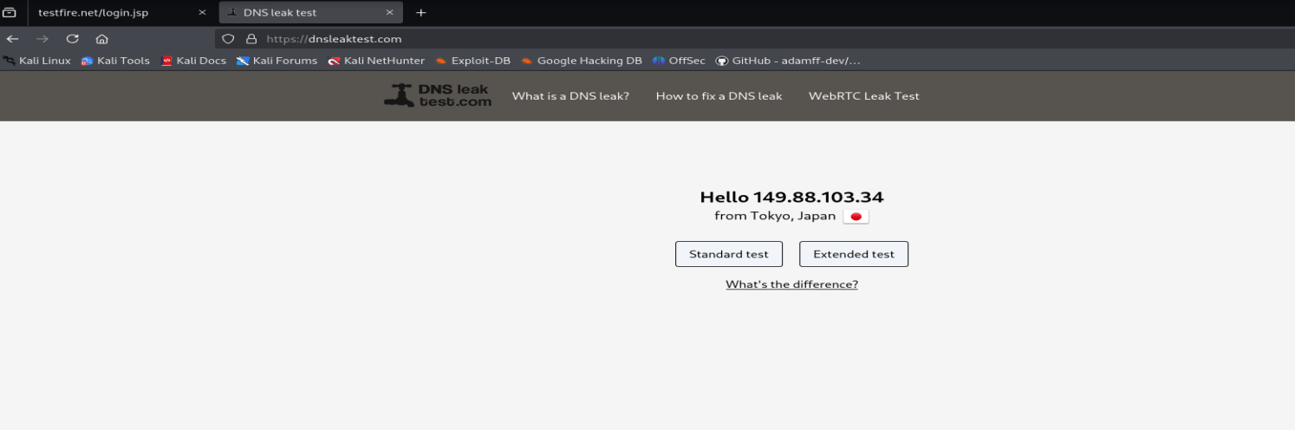

After VPN

**🔸 4. Performance Check**

| **Status** | **Website Access** | **Speed** |
| --- | --- | --- |
| With VPN | Encrypted & Secure (SSL) | Slightly slower |
| Without VPN | Normal | Faster |

**🔸 5. VPN Encryption & Privacy Features**

* Uses **AES-256 encryption** (military-grade)
* Hides real IP & location from websites and trackers
* Prevents ISP from tracking internet activity
* Can bypass censorship & region blocks
* Some free VPNs may log data (always check privacy policy)

**🔸 6. Summary: Benefits & Limitations of VPNs**

**✅ Benefits**

* Protects identity & data over public Wi-Fi
* Encrypts traffic, making it unreadable to attackers
* Hides your IP and browsing activity
* Useful for accessing region-locked content

**❌ Limitations**

* Free VPNs can be **slower**
* Some may **log user data** (less privacy)
* VPNs don’t protect against **malware/phishing**
* May not work well with certain websites or banking apps

**✅ Conclusion:**

Using a VPN improves **online privacy and security** by hiding your IP and encrypting your internet connection. However, users must choose a **trusted provider** and understand both the **benefits and trade-offs**.